Zhulien Mobin - 3191549
-My main goal was to improve the predictiveFiring() logic, as it didn’t work before because it was using unnecessary variables(variable names: enemyDirection, dx, dy, target_distance) plus doing wrong calculations(variable names: enemyX, enemyY, target_distance), which rendered it useless. My secondary goal(if time allowed) was to improve the overall code quality, hence the troubleshooting branch I created. I prioritised quality over quantity.
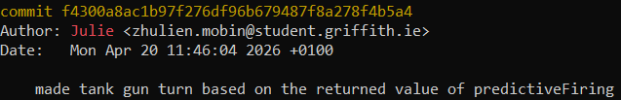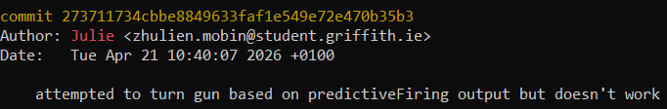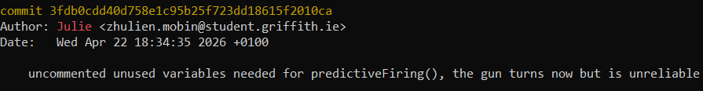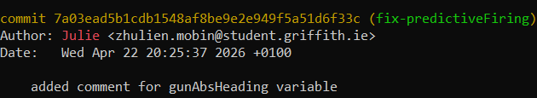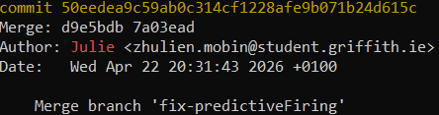
Zhulien Mobin - 3191549
-predictiveFiring() went from:
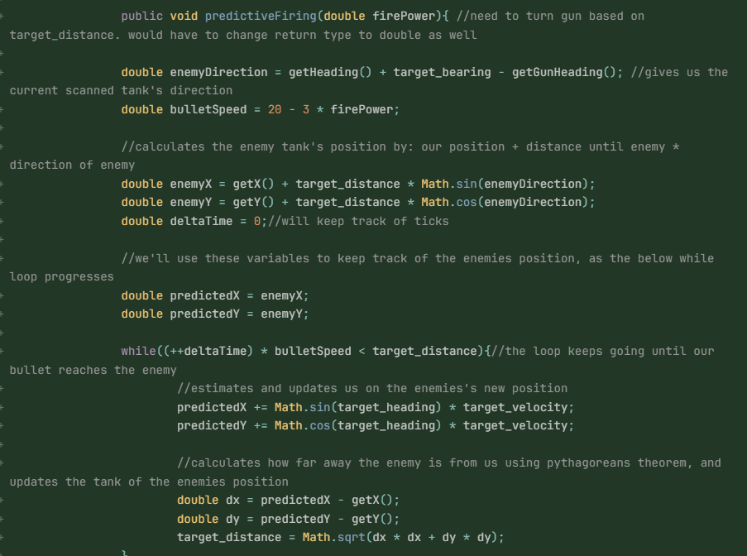
-to:
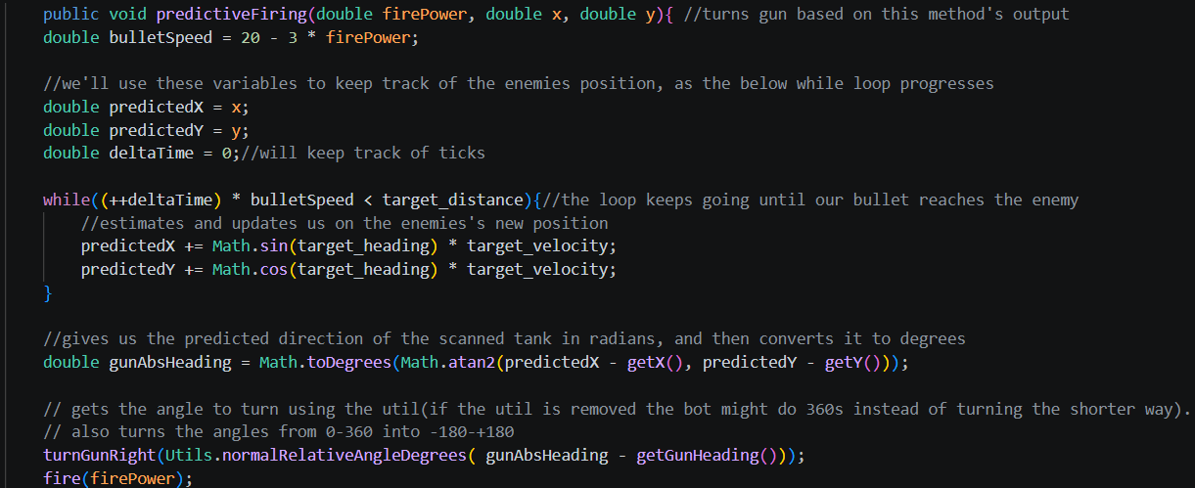
-I did a good amount of test battles(which the results of can be found below) with our tank by fully disabling everything but onScannedRobot() and predictiveFiring(). Our win rate was always above 50% against tanks like “Crazy”, with more erratic movement.
Amaterasu vs Crazy 100 rounds results
Amaterasu vs 23 other bots 100 rounds results
Zhulien Mobin - 3191549
For the next review, I would like to play around with onHitByBullet(), onBulletHit(), onHitRobot() methods and overall tank movement. I would additionally like to attempt at making our code flow together a bit better, since at the moment it feels chaotic.
GitLab Repository URL

